







UID /get/

ReadySetResource.com

Contents

8.1 - Company Details 3

8.2 - Solutions 4

8.3 - Payment Method 5

8.4 - UID /home/ Work Log 6

# 8.1 - Company Details

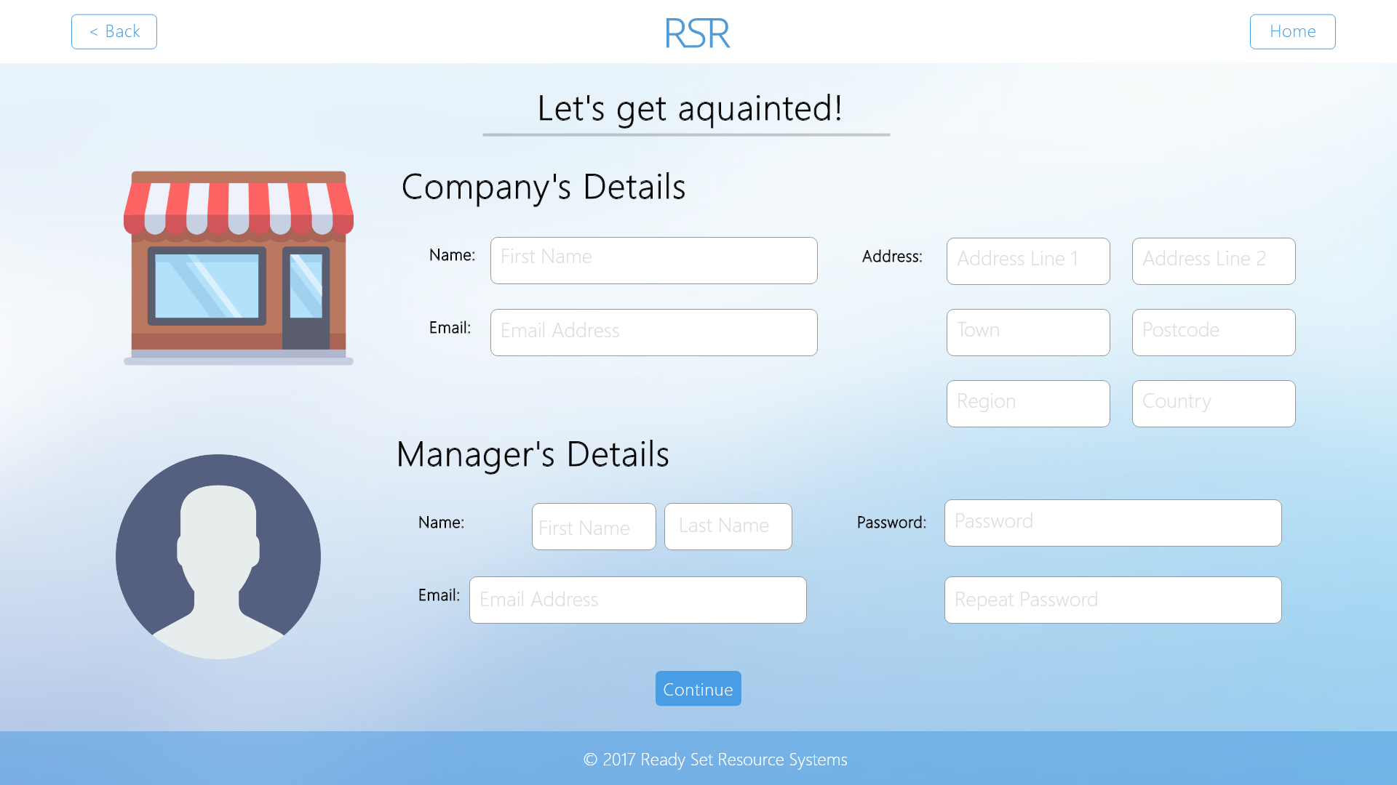

Input Permissible: - Company Name

- Company Email Address

- Company Address Line 1

- Company Address Line 2

- Company Town

- Company Postcode

- Company Region

- Company Country

- Manager First Name

- Manager Last Name

- Manager Password

- Manager Repeat Password

- Manager Email Address

Error Messages: - ‘Please complete all fields’

- ‘Your passwords do not match.’

- ‘Your email is wrongly formatted’

# 8.2 - Solutions

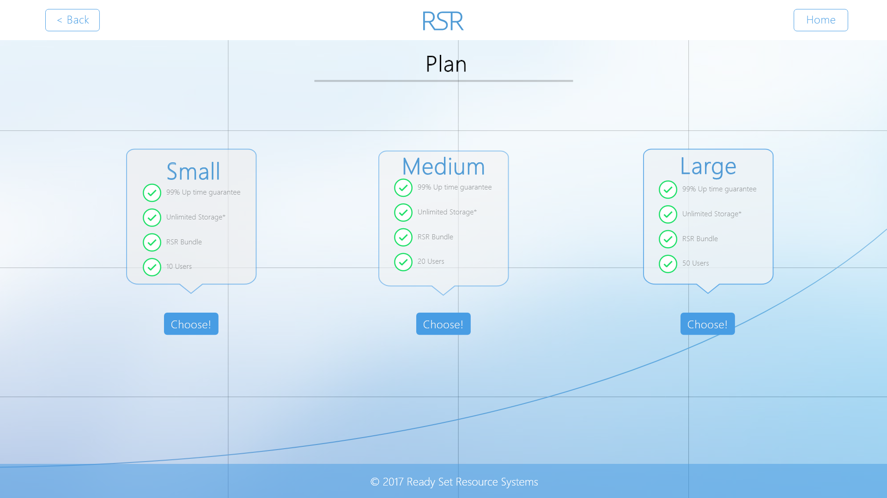

Input Permissible: None

Error Messages: None

# 8.3 - Payment Method

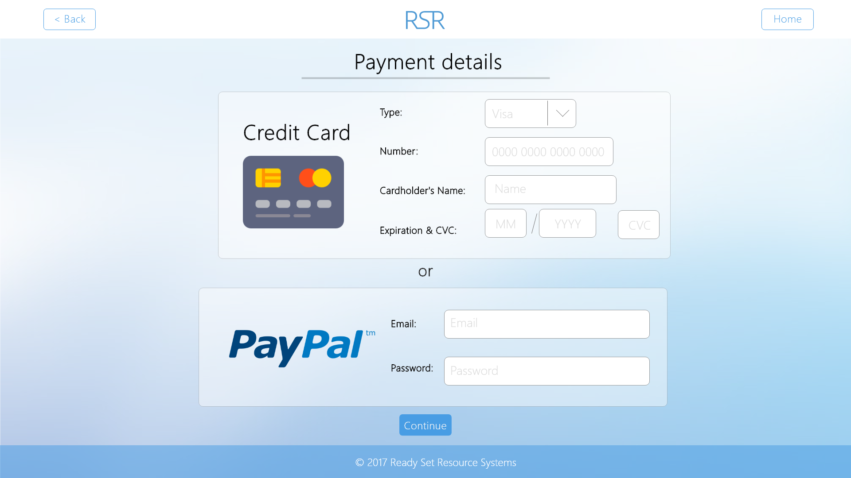

Input Permissible: - Type

- Number

- Cardholder’s Name

- Expiration

- Security Code

- Email

- Password

Error Messages: - ‘Please complete all fields’

- ‘Payment details unsuccessful’

# 8.4 - UID /get/ Work Log

| Entry | Description | Person | Date | Mins Spent |
| --- | --- | --- | --- | --- |
| 1 | Formatted the document | Aidan Marshall | 19/3/18 | 6 |
| 2 | Designed the website | Aidan Marshall | 19/3/18 | 66 |
| 3 | Added screenshots and page details | Aidan Marshall | 19/3/18 | 9 |
| 81 | | | | |